WPL

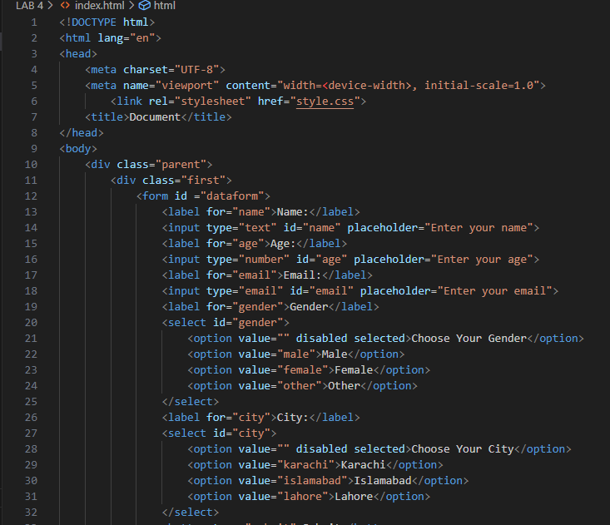

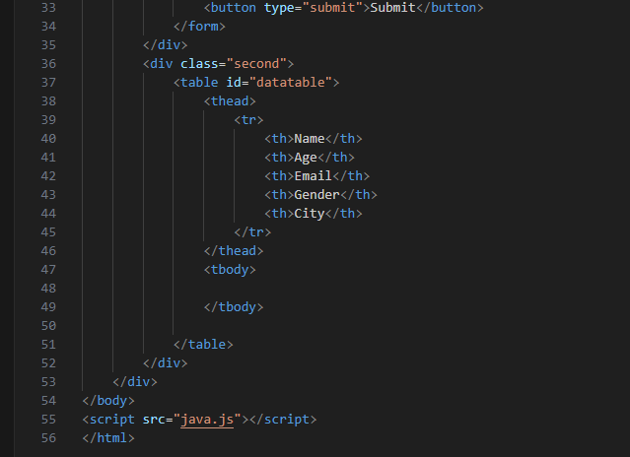

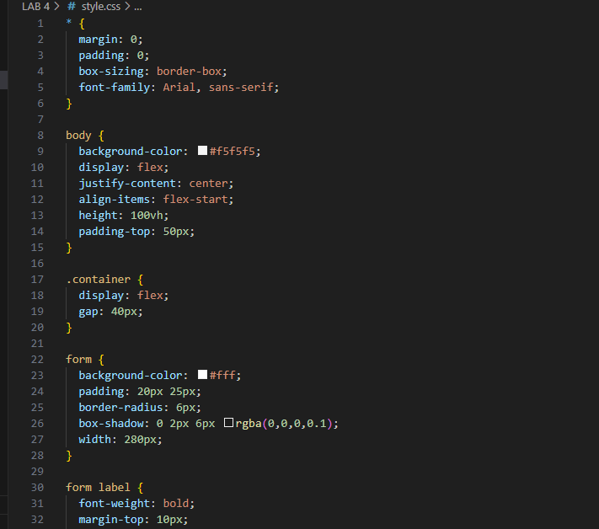
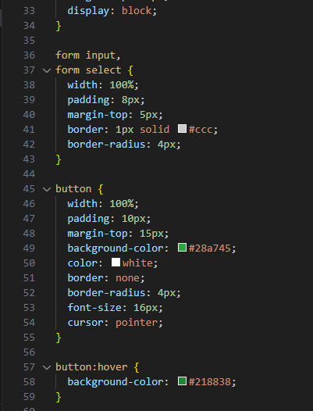

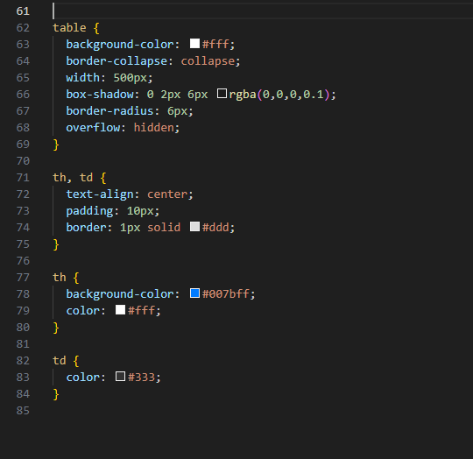

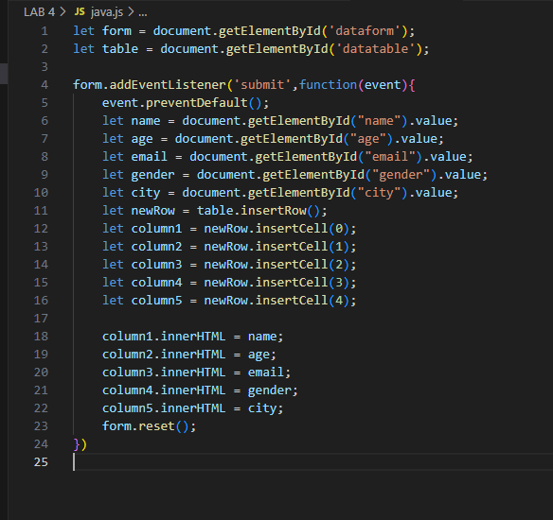

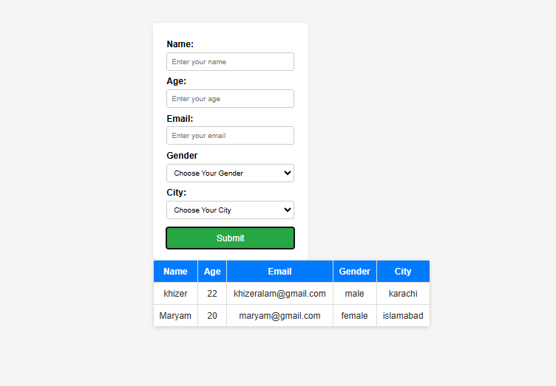

<!DOCTYPE html>
<html lang="en">
<head>
<meta charset="UTF-8">
<meta name="viewport" content="width=<device-width>, initial-scale=1.0">
<link rel="stylesheet" href="style.css">
<title>Document</title>
</head>
<body>
<div class="parent">
<div class="first">
<form id ="dataform">
<label for="name">Name:</label>
<input type="text" id="name" placeholder="Enter your name">
<label for="age">Age:</label>
<input type="number" id="age" placeholder="Enter your age">
<label for="email">Email:</label>
<input type="email" id="email" placeholder="Enter your email">
<label for="gender">Gender</label>
<select id="gender">
<option value="" disabled selected>Choose Your Gender</option>
<option value="male">Male</option>
<option value="female">Female</option>
<option value="other">Other</option>
</select>
<label for="city">City:</label>
<select id="city">
<option value="" disabled selected>Choose Your City</option>
<option value="karachi">Karachi</option>
<option value="islamabad">Islamabad</option>
<option value="lahore">Lahore</option>
</select>
<button type="submit">Submit</button>
</form>
</div>
<div class="second">
<table id="datatable">
<thead>
<tr>
<th>Name</th>
<th>Age</th>
<th>Email</th>
<th>Gender</th>
<th>City</th>
</tr>
</thead>
<tbody>

</tbody>

</table>
</div>
</div>
</body>
<script src="java.js"></script>
</html>

* {
margin: 0;
padding: 0;
box-sizing: border-box;
font-family: Arial, sans-serif;
}

body {
background-color: #f5f5f5;
display: flex;
justify-content: center;
align-items: flex-start;
height: 100vh;
padding-top: 50px;
}

.container {
display: flex;
gap: 40px;
}

form {
background-color: #fff;
padding: 20px 25px;
border-radius: 6px;
box-shadow: 0 2px 6px rgba(0,0,0,0.1);
width: 280px;
}

form label {
font-weight: bold;
margin-top: 10px;
display: block;
}

form input,
form select {
width: 100%;
padding: 8px;
margin-top: 5px;
border: 1px solid #ccc;
border-radius: 4px;
}

button {
width: 100%;
padding: 10px;
margin-top: 15px;
background-color: #28a745;
color: white;
border: none;
border-radius: 4px;
font-size: 16px;
cursor: pointer;
}

button:hover {
background-color: #218838;
}

table {
background-color: #fff;
border-collapse: collapse;
width: 500px;
box-shadow: 0 2px 6px rgba(0,0,0,0.1);
border-radius: 6px;
overflow: hidden;
}

th, td {
text-align: center;
padding: 10px;
border: 1px solid #ddd;
}

th {
background-color: #007bff;
color: #fff;
}

td {
color: #333;
}

let form = document.getElementById('dataform');
let table = document.getElementById('datatable');

form.addEventListener('submit',function(event){
event.preventDefault();
let name = document.getElementById("name").value;
let age = document.getElementById("age").value;
let email = document.getElementById("email").value;
let gender = document.getElementById("gender").value;
let city = document.getElementById("city").value;
let newRow = table.insertRow();
let column1 = newRow.insertCell(0);
let column2 = newRow.insertCell(1);
let column3 = newRow.insertCell(2);
let column4 = newRow.insertCell(3);
let column5 = newRow.insertCell(4);

column1.innerHTML = name;
column2.innerHTML = age;
column3.innerHTML = email;
column4.innerHTML = gender;
column5.innerHTML = city;
form.reset();
})

